ACME TRAVELER PROFILE
CONFIDENTIAL
Date Completed: 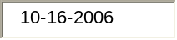Is This A New Profile? Yes?  No? Existing: Yes? No?

Company
Name: 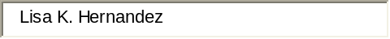Title: 
Employee ID#: 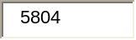Dept Name: 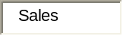
Business Street Address:
City: State: Zip: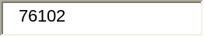
SSN#: 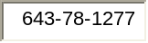
Passport #: 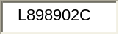
Country of Origin:  Expiration Date: 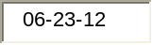
Office Tel. Number(s): 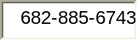 Office Fax Number: 
E-mail Address:
Aircraft Seating Preference:  NonSmoking:   Smoking:   Window:  Aisle: | Frequent Flyer Programs:  Airline 1: Number: 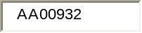  Airline 2: Number: 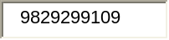  Airline 3: Number: 
Special Meal Request(s):
Airline Club Memberships:
Hotel Club Memberships:  Hotel Company 1: Number:  Hotel Company 2: Number: | Car Club Memberships:  Car Company 1: Number:  Car Company 2: Number:

Authorization for Corporate Card Charge:
Card Type Card # 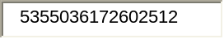EXP
AUTHORIZATION
The undersigned traveler and the Company hereby authorize Acme Travel to charge to the credit card account(s) (through signature on file) as indicated on this form.

